Lead Generation Process

1. Google Form – Food Delivery App Lead Collection
Form Title: Food Delivery App – Get Early Access
Description:
Sign up to get early access, special discounts, and exciting offers from our new food delivery app.
Fields:
- Full Name — Short Answer
- Email Address — Short Answer
- Phone Number — Short Answer
- Favorite Cuisine — Multiple Choice
  - Indian
  - Chinese
  - Italian
  - Fast Food
  - South Indian
Test Entry:
- Name: Jignesh Parmar
- Email: jignesh@example.com
- Phone: 9876543210
- Favorite Cuisine: Indian
Submission requirement: Create the form in Google Forms, submit the above test entry, and copy the generated Form URL for your assignment.

2. Landing Page Mockup – Zomato-Style Offer
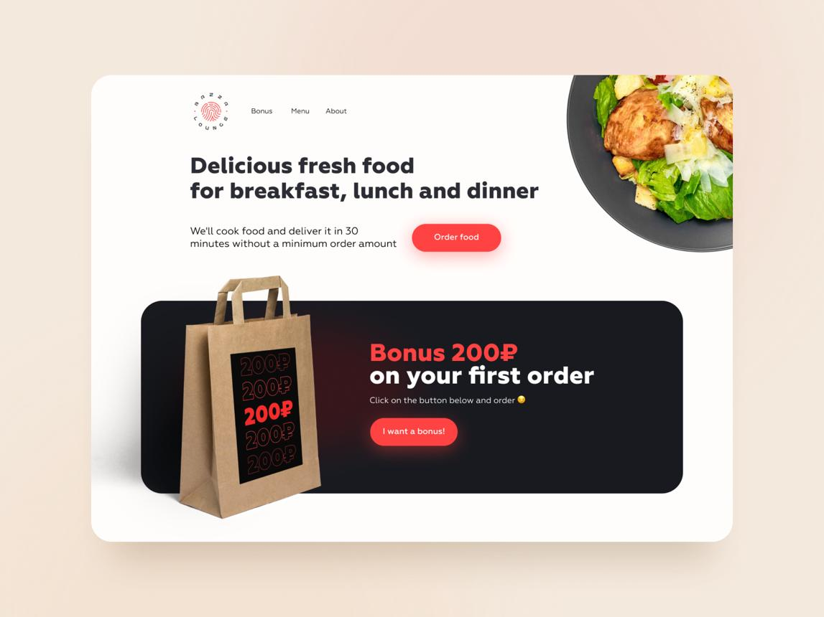
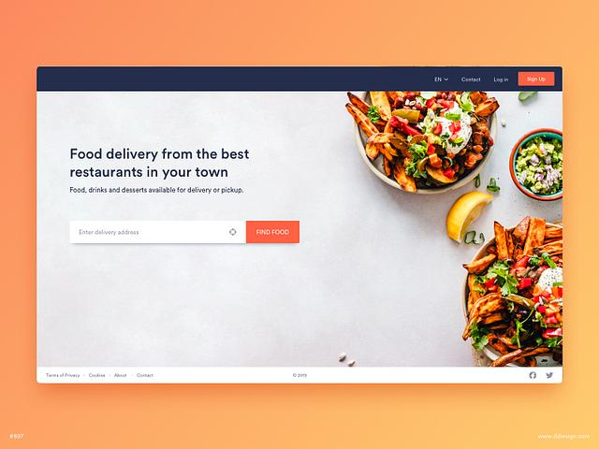
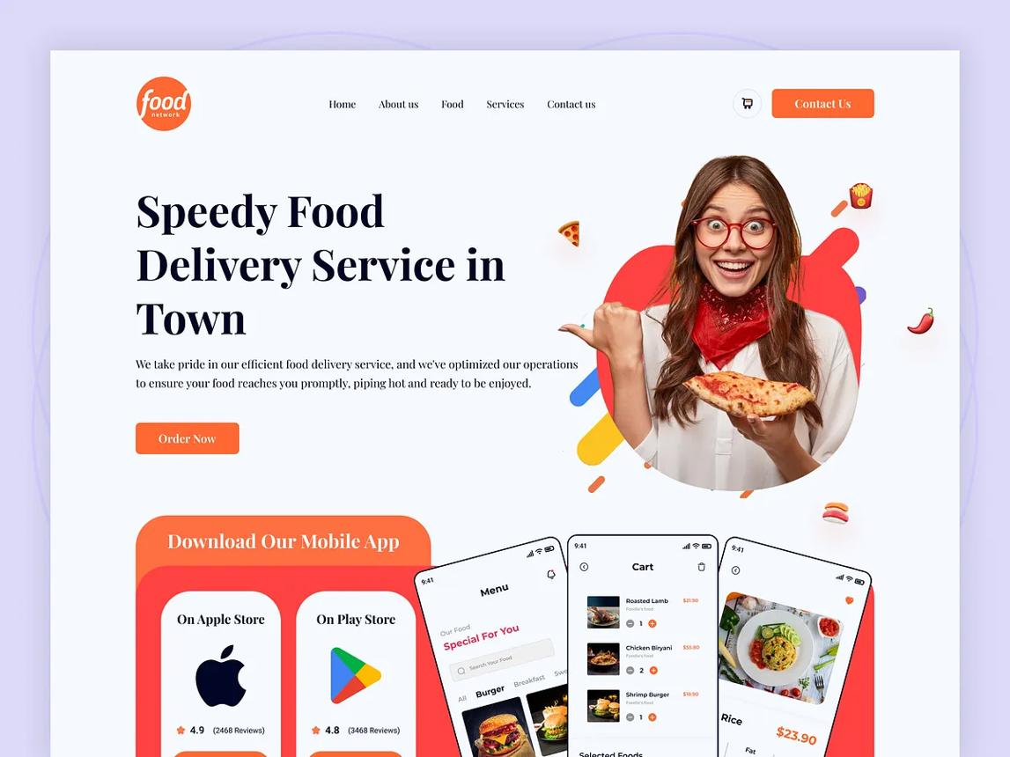
6
Headline:
🍕 Delicious Food. Amazing Deals. Delivered Fast!
Special Deal:
🔥 Get 50% OFF on Your First Order
Supporting Text:
Sign up today and enjoy exclusive food offers, exciting discounts, and fast doorstep delivery.
CTA Button:
👉 GET 50% OFF
Email Field:
Enter your email address
Design suggestion: Use a red/white theme, attractive food images, a large discount badge, and a prominent CTA button.

3. Lead Magnets – Music Streaming App
Lead Magnet | How it Collects User Information
🎵 30-Day Free Trial | Users enter their name, email, and sometimes phone/payment details to activate the trial.
🎧 Exclusive Playlist | Users submit their email address to unlock a special curated playlist.
🎟️ Discount Coupon | Users provide their email or phone number to receive a discount coupon.

4. WhatsApp Lead Follow-Up – IPL Fantasy League App
Hi [Name]! 👋
Thanks for showing interest in our IPL Fantasy League app 🏏🔥
Create your fantasy team, compete with other cricket fans, and get a chance to win exciting rewards!
👉 Sign up now and start building your winning team: [App Link]
Good luck! 🏆

5. Five Catchy Headlines – Electronics Sale
AI Prompt Used:
"Write 5 catchy headlines to attract users to sign up for early access to a big online electronics sale."
- 🔥 Big Electronics Sale Is Coming — Get Early Access!
- ⚡ Smart Deals. Bigger Savings. Sign Up First!
- 📱 Your Favorite Gadgets at Unbelievable Prices!
- 🎉 Be the First to Unlock Our Biggest Electronics Deals!
- 🚀 Early Access = First Pick of the Best Tech Deals!
Best headline for lead generation:
👉 Big Electronics Sale Is Coming — Get Early Access!

